**DBMS - Mini Project**

**Event Management System**

Submitted By:

Name: K S Ramalakshmi

SRN: PES1UG20CS186

V Semester Section D

**Short Description and Scope of the Project**

**What is an Event Management System?**

Data organisation is a very essential skill to ensure effective customer service and business improvements. A simple full stack web application to keep track of ongoing events, attendee details, host details and event organisation records. Target Users who include the event managers, and event hosts can use the system efficiently to keep track of events and aid in better organisation of the same.

Scope of the Project

Currently the project accepts records, displays on request, updates specific fields for specific records and deletes records on request. The existing CRUD operations can be made more dynamic and optimized. Increased views to display user and event statistics can be included to provide end-to-end features of a data management platform.

ER Diagram

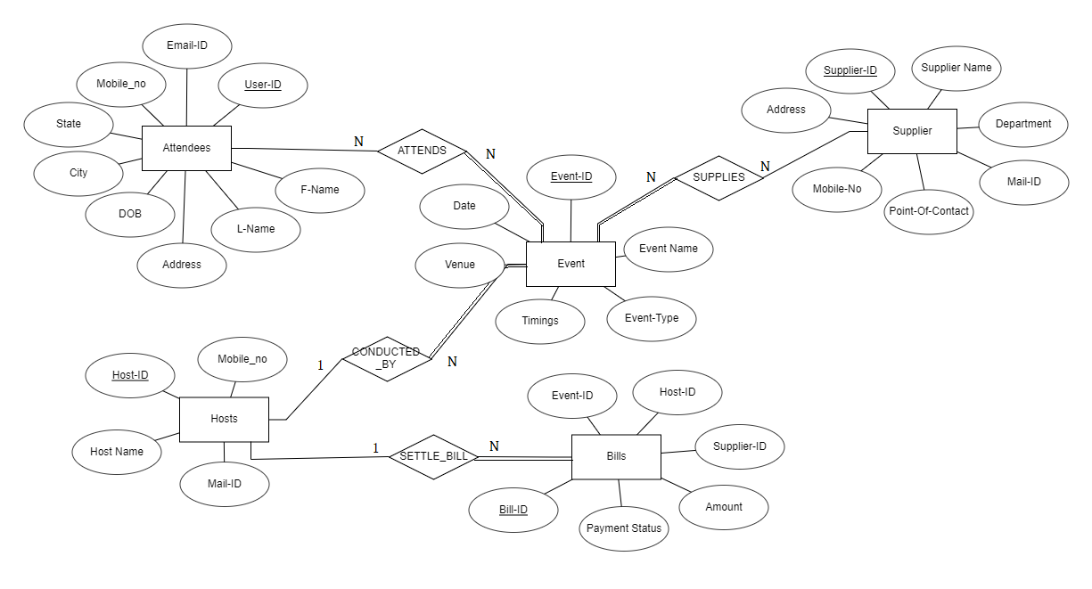

**Relational Schema**

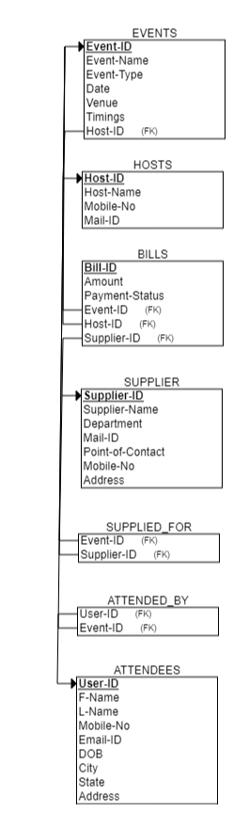

**DDL statements - Building the database**

**Populating the Database**

**Join Queries**

Showcase at least 4 join queries

Write the query in English Language, Show the equivalent SQL statement and also a screenshot of the query and the results

**Aggregate Functions**

Showcase at least 4 Aggregate function queries

Write the query in English Language, Show the equivalent SQL statement and also a screenshot of the query and the results

**Set Operations**

Showcase at least 4 Set Operations queries

Write the query in English Language, Show the equivalent SQL statement and also a screenshot of the query and the results

**Functions and Procedures**

Create a Function and Procedure. State the objective of the function / Procedure. Run and display the results.

**Triggers and Cursors**

Create a Trigger and a Cursor. State the objective. Run and display the results.

**Developing a Frontend**

The frontend should support

1. Addition, Modification and Deletion of records from any chosen table 2. There should be an window to accept and run any SQL statement and display the result